Microsoft Teams Enhancements
Official URL: https://services.smsu.edu/TDClient/180/Portal/KB/Article/3049/Microsoft-Teams-Enhancements
Category: Knowledge Base > Information Technology Services > Software and Applications > Microsoft Teams Enhancements
Tags: teams, microsoft
_____________________________________________________

Overview
Exciting news from the Office 365 Team! Beginning Monday, October 7, 2019 faculty and staff will gain the ability to create their own Microsoft Teams in the O365 Shared Tenant.

What is Microsoft Teams?
In short, Teams is a shared workspace where groups can communicate more effectively. The space can be used for group or one-on-one chats, online meetings (with or without video), sharing files, and working with Office 365 applications, fostering and supporting effective communication.

How does this work?
This enhancement is available to faculty and staff that are currently members of the Minnesota State O365 Shared Tenant. Students cannot create Teams. Faculty and staff may create teams for students at their discretion.
Teams can be created using either the native Microsoft Teams desktop application (installed locally on your computer) or using the Teams app in the Office 365 online portal.
Each Team created will follow a predefined naming convention. Names will be automatically prefaced with the designated Shared Tenant abbreviation of the Team creator’s primary campus. Names will also include “-Team” as a suffix. For example, if a Hennepin Technical College faculty member wishes to create the “Bio101-03_Fall 2019” Team, the final Team name will automatically convert to, “HTC-Bio101-03_Fall 2019-Team”.
It is important to note that the Team name preface will be based on the creator’s primary campus. This is especially noteworthy for faculty and staff with multiple campus associations. For example, an employee may be associated with both Hennepin Technical College and Rochester Community and Technical College. If Rochester is listed as their primary campus, all Teams created by this user will begin with “RCTC-“.

Is the creator also the person that administers the Team? Can there be more than one administrator?
Once the team is created, your account will be set as the Owner of the team. Owners are the administrators of the Team site. There can be more than one owner of a Team. Click here to learn more about adding members and assigning roles.

What steps do I take to create a Team?
- Open Microsoft Teams (on your computer or via the Office 365 portal.)

Figure 1: Uploaded Image (Thumbnail)

Figure 2: Uploaded Image (Thumbnail)
- From the “Teams” view, select “Join or create a team”.
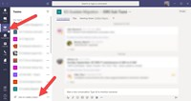
Figure 3: Uploaded Image (Thumbnail)
- Select the button to Create Team.
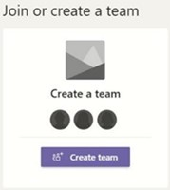
Figure 4: Uploaded Image (Thumbnail)
- Select the type of team that you want to create. Click here for information describing the differences between the types of teams.
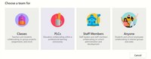
Figure 5: Uploaded Image (Thumbnail)
- Enter the Name for your team. You do not need to type the campus prefix – this will be added automatically. Use a name that clearly defines the Team’s purpose and audience. Additionally, provide a Description of the Team, then click NEXT.
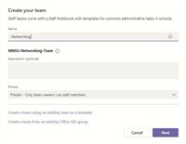
Figure 6: Uploaded Image (Thumbnail)
- A prompt will provide the opportunity to add members to the Team. Members may be added at this time, or you may choose to Skip the step and add members later. Ability to add and remove members at your discretion will be available once the Team creation process is completed.
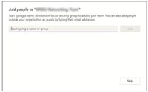
Figure 7: Uploaded Image (Thumbnail)
- Once your Team is created, it will appear in the list of the “Teams” view.

Additional Resources
- Microsoft Teams help & learning
- Microsoft Teams video training

Accessibility Review & Update Log:
- [x] Content accuracy and link integrity verified
- [x] High-contrast visual hierarchy implemented (Inter and Calibri)
- [x] Image alt-text captions verified (all screenshots captioned)
- [x] Outline headers and standard list sequences optimized for screen readers

